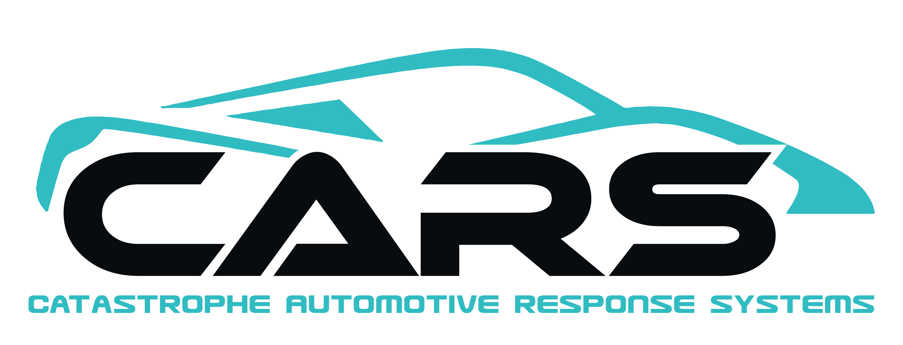

866-996-3368

Our Promise

We at CARS promise that every customer we encounter is treated like family. Our highly skilled and professional techs are dedicated to making your experience with paintless dent repair a memorable one, and an experience that you will be happy to share with friends and family!

You have my personal guarantee!

JBS Signature

Follow these steps when you have an auto hail claim:

- Contact your insurance company to see if your policy covers hail damage.
- Get your vehicle scheduled for an estimate by your insurance adjuster.
- Clean your vehicle, so that the adjuster can see all the damage.
- Let the Adjuster know that you would like CARS to do your repairs.
- Call CARS @ 866-996-3368 to schedule your repair date.
- Drop off your vehicle and take out any belongings you may need.
- 1-3 days later pick you vehicle up.
- Refer friends and family based on how well CARS performed on your paintless dent repair.

WWW.CARSPDR.COM

Certified Hail Experts

866-996-3368

Your Satisfaction is Our Guarantee!

PAINTLESS DENT REMOVAL

My car has hail damage, now what?

Q. What is PDR?
PDR is a skilled craft that highly trained technicians use specialized tools and lighting to restore dents from the underside of the vehicle panels to bring it back to its pre accident condition and strength.
Q. Does PDR use Dry Ice?
NO, dry ice will burn the paint when touched.
Q. How long will the process take?
On average, most hail claims that are done using just the PDR process take between 1-3 days. If traditional conventional repairs are needed it will take more time due to parts and painting.

866-996-3368 www.carspdr.com
ARC LOGO / NAPDRT LOGO / PDR NATION LOGO
Q. Can all hail damage be fixed by PDR method?
No, sometimes the damage is so severe that conventional repair is needed to fix some panels.
Q. What is pre-loss condition?
It is the condition of the vehicle that is noted during the estimate process. Any damage that is found during the hail estimate including all unrelated prior damage is considered pre-loss condition.
Q. What is a Supplement?
Supplements are additional operations or parts that are missed on the original estimate that are necessary to complete the repair process.

Q. Why use PDR over Conventional repair?
- PDR is a much less invasive repair process.
- With PDR you maintain your original factory finish, which in turn will maintain the value of your vehicle higher at trade in or resale.
- Both processes are valid and necessary at times. By combining the two we are able to cut the repair process down and getting your vehicle back to you sooner.

