Certified Hail experts

FRONT COVER OF BOOKLET

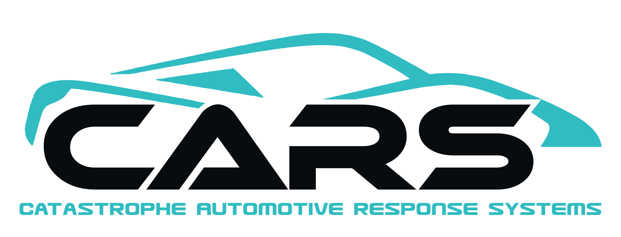
866-996-3368

Your satisfaction is Our Guarantee!
PAINTLESS DENT REMOVAL

BACK COVER

Our Promise

We at CARS promise that every customer we encounter is treated like family. Our highly skilled and professional techs are dedicated to making your experience with paintless dent repair a memorable one, and an experience that you will be happy to share with friends and family!

You have my personal guarantee!
MY SIGNATURE

866-996-3368  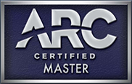 WWW.CARSPDR.COM
866-996-3368 WWW.CARSPDR.COM
PG 1
Why choose CARS as your PDR Partner?
- Dealing with an Actual business owner.
- All Technicians carry Work Comp and Garage Keepers Ins. Which keeps you audit proof!!
- Professional looking and highly skilled technicians that represent your business.
- Handle all aspects of the Hail Claim process: writing estimates, scheduling, supplements, repairs and delivery.
- We stay until the last car is completed and even return for straggler vehicles once the storm is over.
- Assist with CAT Teams Catastrophes

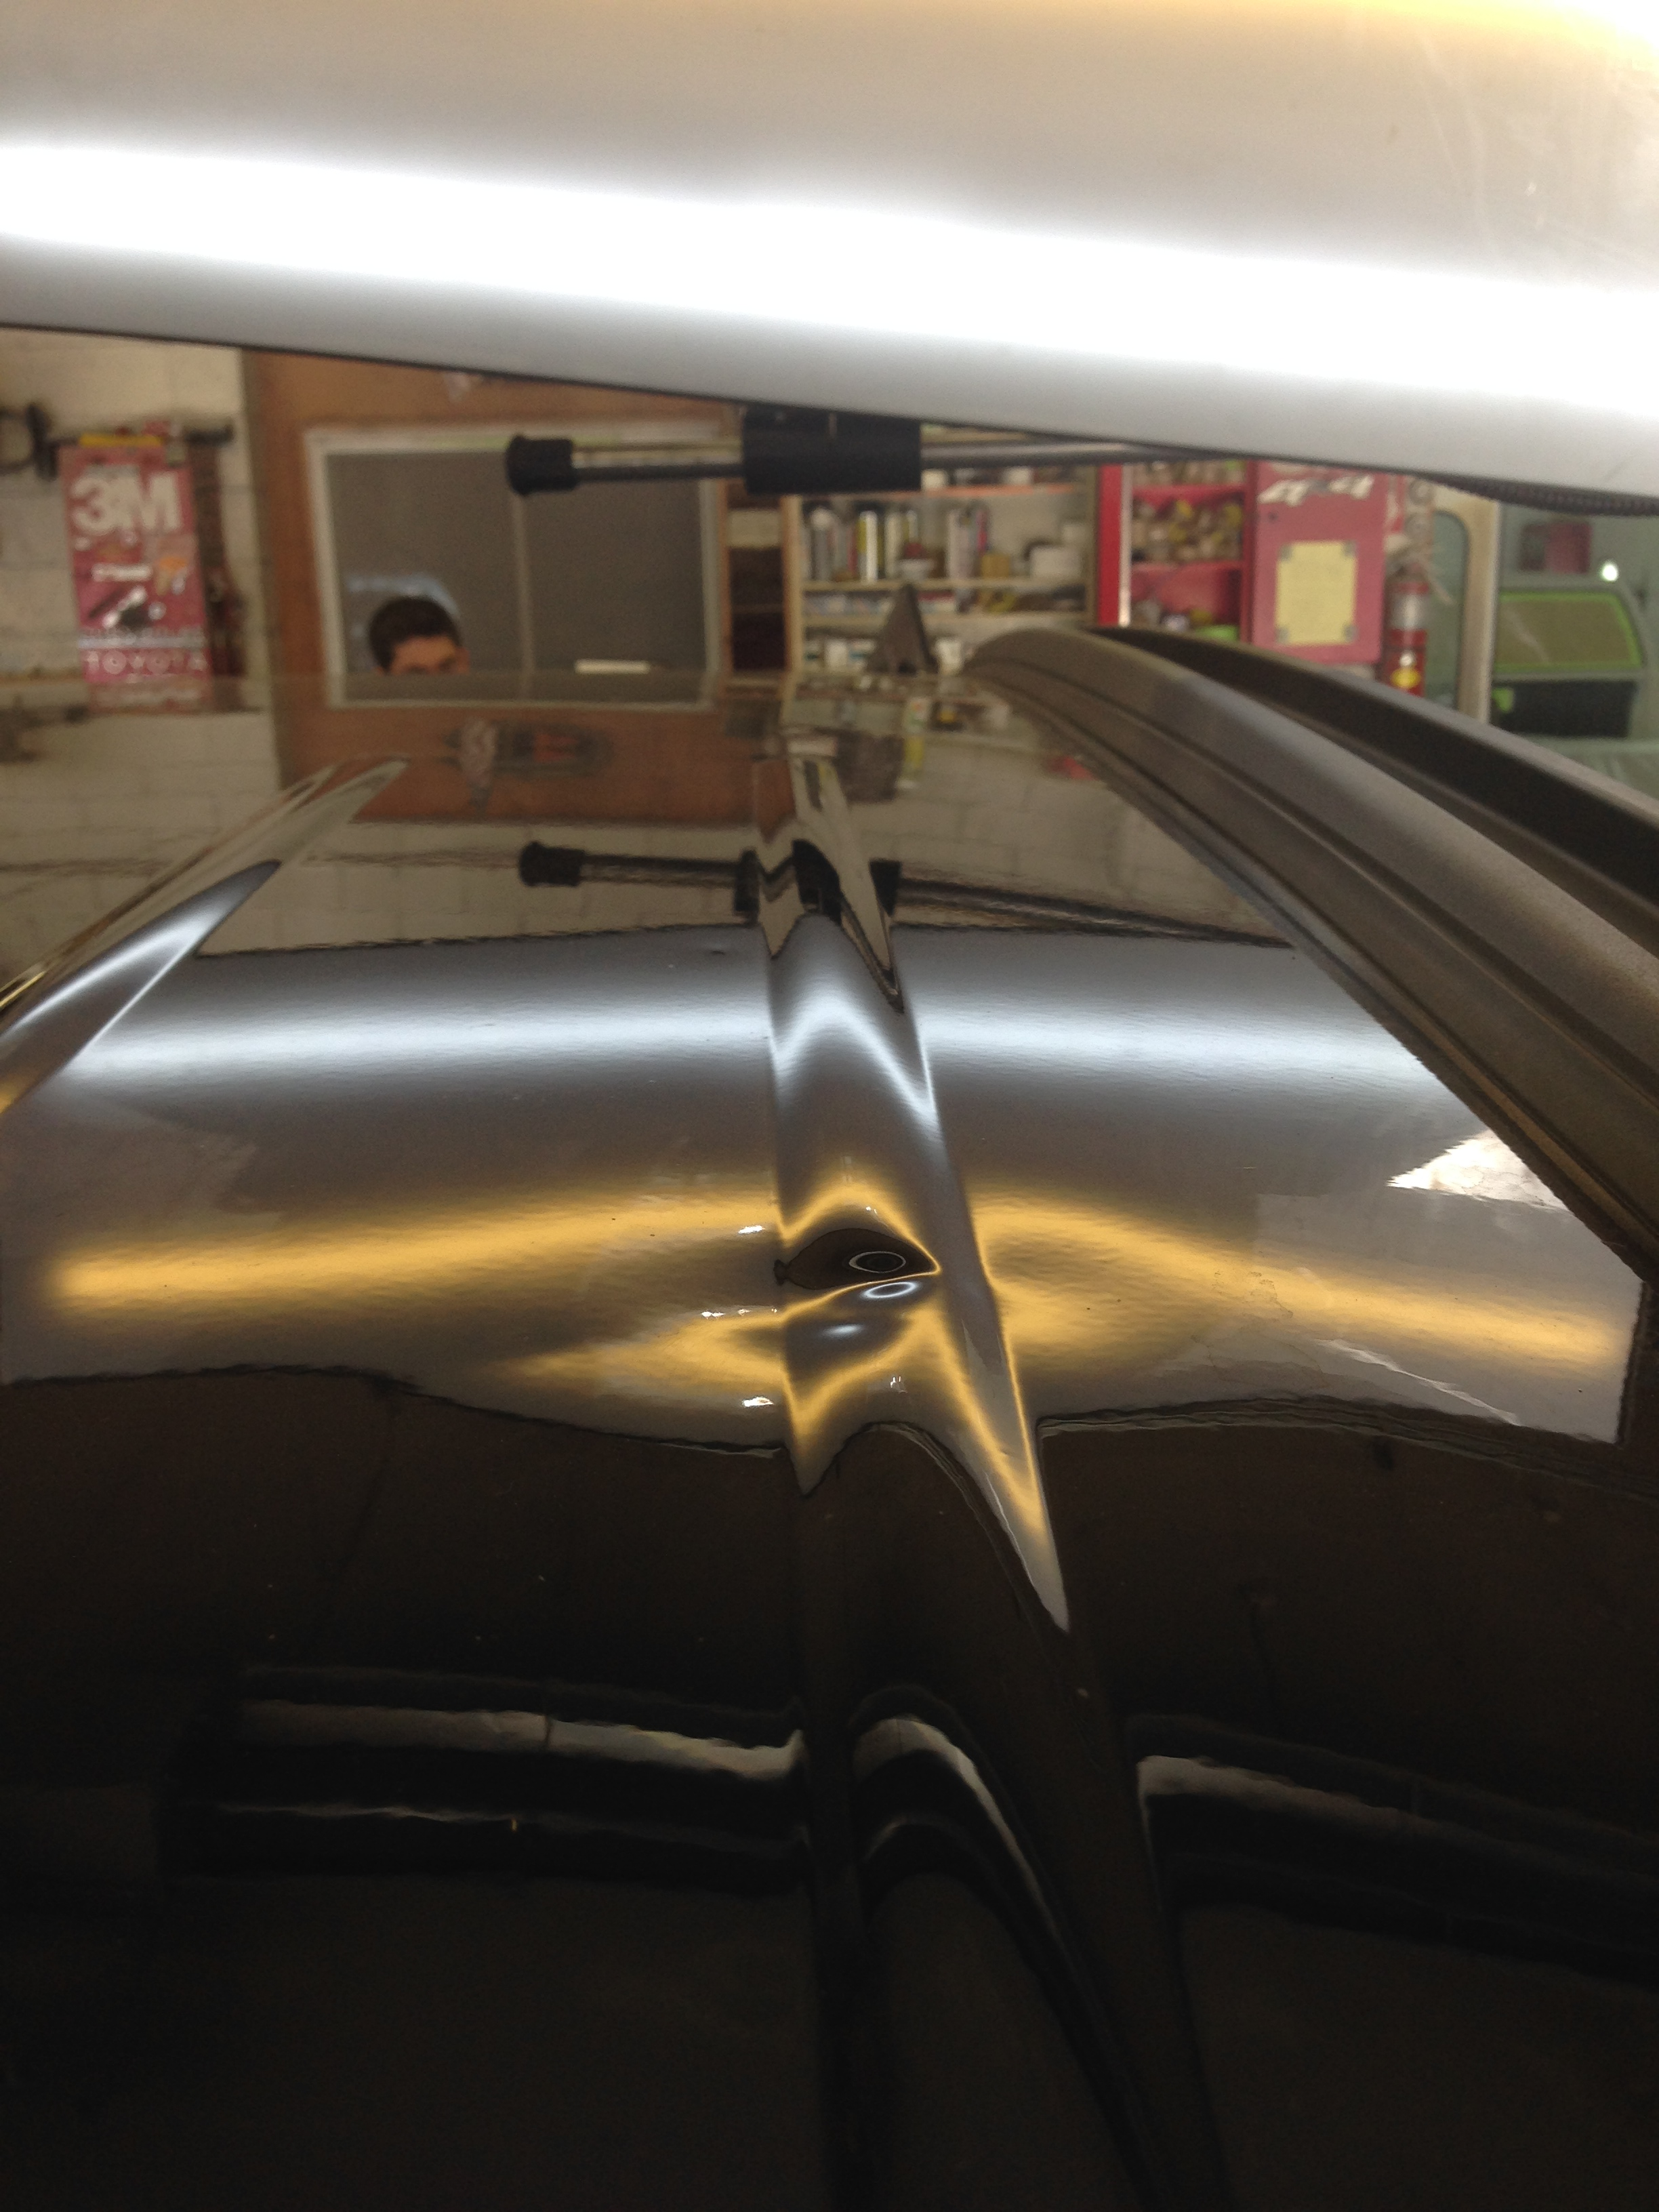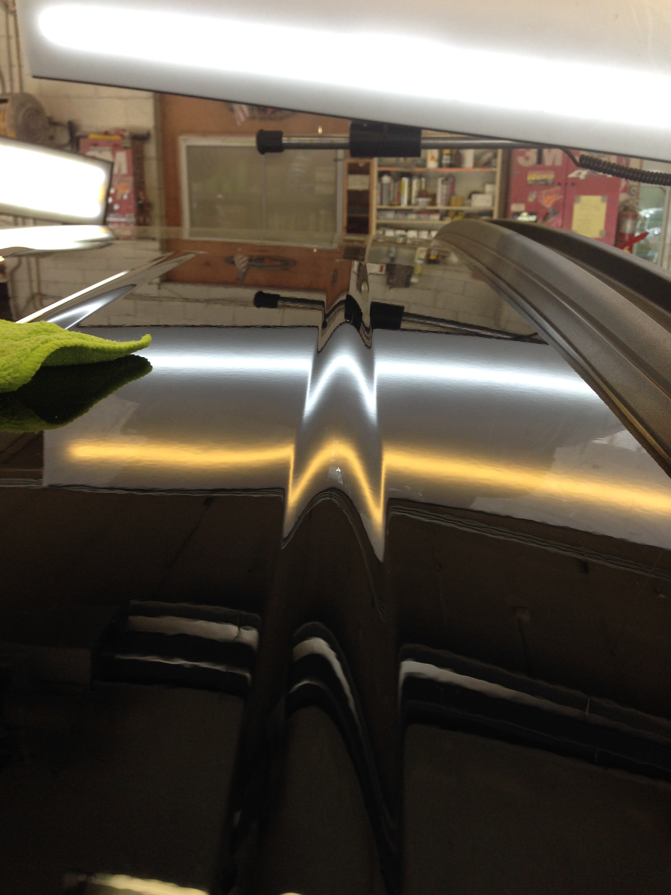
866-996-3368 WWW.CARSPDR.COM
PG 2

As a CARS Partner, What are your Benefits?
- We pay you a % on all repairs done in your facility.
- No additional overhead, with a pre-planned strategy.
- Reduced Cycle times.
- We write all Hail Estimates.
- We help with all supplements if needed.
- We help with scheduling the PDR repairs.
- We work with Insurance Adj. to get retail pricing on all estimates and supplements when needed.
- We help with all follow up phone calls to schedule in the estimates that haven’t yet been worked on.
- We offer a Full Lifetime warranty on all PDR repairs performed by CARS.
- We offer literature and website to educate the cutomers on what PDR and its process.
- We market the local community to try and capture maximum claim opportunities.
- We staff your facility with however many techs are necessary to capture as much volume as possible.
866-996-3368 WWW.CARSPDR.COM
PG 6

(Company Name, Address, City, State,Zip)

has agreed to enter into a partnership with CARS for all of their Hail Claim Repairs. You agree by signing this as of the date noted in below, that CARS and the above company will be Partners on all Hail Claims that are scheduled. This Partnership agreement will remain in effect until such time as either the Company noted as well as CARS has been notified in writing the intend to terminate the partnership. The agreement will terminate 30 days after the written notice is received by receiving party.

______________________________ _____________________________
(Company Rep) date (CARS Rep) date

______________________________ Email to: jstonitsch@carspdr.com
Personal Signature date

866-996-3368 WWW.CARSPDR.COM

PG 4
REFERENCES!

We are PDR provider that works with many Insurance carriers, when it comes to Hail Claims.
Progressive Travelers Eris
Am Fam SF USAA
Geico Cincinnati Auto Owners
Nationwide Farm Bureau Hastings Mutual

Body Shop Partners
Please contact our office at 866-996-3368 for body shop references!

866-996-3368 WWW.CARSPDR.COM
Pg 3
When Estimating Hail Damage
- Be sure the vehicle is inside and under lighting to ensure you get the best reflection. (a clean vehicle is best)
- If you are unable to bring the vehicle inside, find a reflection so that it will help you better see the dents. (Buildings, Poles, Wires, etc.)
- Add all proper R&I times for each process. (Headliner, Hood & liner, Deck & Liner, Lights, Trim panels, etc.)
- For any double panels, Add 25% up charge due to limited access. (Rails, upper part of doors, some Qtr panel, etc.)
- Add 25% for all Aluminum and High Strength Steel panels due to the difficulty of repairing them.
- Add $40 per Dent that is over the size of a half dollar and $80 per Dent that is Hen egg size.
- On side damage, look down the side of the panel “Not” directly at the panel.

Limited Lifetime Warranty
We guarantee all of our work with a limited lifetime warranty. If you are not 100% completely satisfied with our work on your vehicle, we will re-access our work, and make any additional repairs that are necessary.

Lifetime Warranty Verbiage
In the event that CARS paintless dent repair process results are found to be defective under this warranty, CARS will repair such dents proved to be defective as a result of the CARS PDR process, with CARS providing the labor and materials free of charge during the warranty period. All of CARS LIMITED LIFETIME WARRANTIES are subject to exception and limitations pursuant to the written conditions agreed upon by the consumer and the CARS representative prior to the commencement of work. CARS paintless dent repair process guarantee’s against: Shine/gloss deterioration, Blistering, Peeling, Wrinkling, and Defects in Primer adhesion. CARS will warrant that the paintless dent repair process will last for as long as you own your vehicle. (Non transferable)
Exclusions include:
1. PREVIOUS DAMAGE: All previous and unrelated damage not associated with the hail damage repair work provided by CARS is not covered by CARS under this warranty. This warranty applies to the panels, which are repaired by CARS. It covers your vehicle under your subsequent ownership during the warranty period. The Warranty period relates exactly to the warranty period provided by the Manufacturer of your vehicle for coverage of defects in paint finish and corrosion. In conclusion, the CARS warranty does not exceed manufacturer’s warranty.
2. SPECIFICALLY EXCLUDED: A. Rust, surface rust, rusts through, and/or damage caused by rusting of or exterior panels is not covered. C. Damage arising from unreasonable vehicle use. D. Faulty care and maintenance. E. Parts, materials, and equipment featuring manufacturers’ warranties.
3. SALE OR LEASE EXCLUSION: In the event of a sale or lease departure of your vehicle, the date of said sale or lease termination is the date that your warranty period expires for your vehicle. This is the date in which your CARS warranty period expires.
4. STRIPES AND DECALS: On factory decorative stripes and decals, only the factory warranty remains.
5. SUBSEQUENT HAIL STORMS: This warranty shall become void if the vehicle is subjected to subsequent hailstorms or if CARS can determine and verify the damage differs from the damage on the original repair order. This LIMITED LIFETIME WARRANTY shall not be varied, supplemented, qualified or interpreted by any prior course of dealings. This LIMITED LIFETIME WARRANTY shall be null and void if the repair is altered, adjusted or tampered with by any person not authorized by CARS. This warranty is nontransferable.

